NAME: RAJA RAYYAN AMEER
REG. NO.: 23-CP-25
SECTION: ALPHA
SUBJECT: ML&AI
DEPARTMENT: COMPUTER ENGINEERING
TEACHER: SIR SHAHID
LAB 4:
Task:
To understand and implement Multiple Linear Regression, where multiple independent variables influence the dependent variable. This lab will focus on core concepts, assumptions, and practical implementation using Python. Students will learn to visualize relationships, interpret results, and evaluate model performance.
Program:
#Step 1: Import Libraries
import pandas as pd
import numpy as np
import matplotlib.pyplot as plt
import seaborn as sns
from sklearn.linear_model import LinearRegression
from sklearn.model_selection import train_test_split
from sklearn.metrics import mean_squared_error,r2_score

#Step 2: Import the Dataset, and Reading
data = pd.read_csv("Lab 4 Laptop Prices Multivariate Dataset.csv")

#Step 3: Data Preprocessing
#Checking for the Missing Values
print("\nMissing Values in the Dataset: \n",data.isnull().sum())

#Handling the Missing Values
#Dependent Values Missing (Target One), Drop Rows
data = data.dropna(subset=["Price_USD"])

#Independent Values (Replacing the Missing Values with Column Means, if there is no Outlier. But if there is any outliers, we will go with the Median Approach)
data["RAM_GB"] = data["RAM_GB"].fillna(data["RAM_GB"].mean())
data["Processor_Speed_GHz"] = data["Processor_Speed_GHz"].fillna(data["Processor_Speed_GHz"].mean())

#Independent Variables
x = data[['RAM_GB','Storage_GB','Processor_Speed_GHz','Screen_Size_Inches']]

#Dependent Variables
y = data['Price_USD']

#Step 4: Train_Test Split
x_train,x_test,y_train,y_test = train_test_split(x,y,test_size=0.2,random_state=42)

#Step 5: Model Training
model = LinearRegression()
model.fit(x_train,y_train)

print("Intercept (c): ",model.intercept_)
print("Slope (m1, m2, m3, m4 respectively): ",model.coef_)

#Step 6: Predicting
y_pred = model.predict(x_test)
comparison = pd.DataFrame({
'Actual':y_test.values,
'Predicted':y_pred})
print(comparison)

#Step 7: Model Evaluation
mse = mean_squared_error(y_test,y_pred)
r2 = r2_score(y_test,y_pred)
print("\n Model Evaluation Metrics \n")
print("Mean Squared Error (MSE): ",mse)
print("R^2 Score: ",r2)

#Step 8: Data Visulization
#Plot Actual vs Predicted Values
plt.figure(figsize = (8,6))
sns.scatterplot(x = y_test, y = y_pred, color = "blue")
plt.plot([y_test.min(),y_test.max()],
[y_test.min(), y_test.max()],
color = "red",
linestyle = "--")
plt.xlabel("Actual Values")
plt.ylabel("Predicted Price")
plt.title("Actual vs Predicted Prices")
plt.show()

#Plot Regression Line
plt.figure(figsize = (8,6))
sns.scatterplot(x = y_pred, y = y_test, color = "blue")
plt.plot([y_pred.min(), y_pred.max()],
[y_pred.min(), y_pred.max()],
color = "red",
linestyle = "-")
plt.xlabel("Predicted Price")
plt.ylabel("Actual Price")
plt.title("Regression Line - Predicted vs Actual")
plt.show()

#Plot Residual Error
residuals = y_test - y_pred

plt.figure(figsize=(8,6))
sns.scatterplot(x=y_pred, y=residuals, color="blue")
plt.axhline(y=0, color='red', linestyle='--')
plt.xlabel("Predicted Price")
plt.ylabel("Residual Error")
plt.title("Residual Plot")
plt.show()
Output:
Missing Values in the Dataset:
RAM_GB 3
Storage_GB 0
Processor_Speed_GHz 2
Screen_Size_Inches 0
Price_USD 2
dtype: int64
Intercept (c): 0.8677005689153248
Slope (m1, m2, m3, m4 respectively): [20.18963225 0.27679565 162.53984705 22.37657981]
Actual Predicted
0 1121.26 1060.621231
1 1071.42 1113.786545
2 1216.21 1200.604649
3 1807.11 1965.578859
4 1749.20 1759.791044
5 1181.37 1220.341181
6 1758.49 1690.485638
7 1700.41 1649.406036
8 1388.20 1339.396988
9 1075.66 1079.847166
10 694.46 812.129212
11 1531.38 1576.798918
12 1252.41 1202.093288
13 1247.68 1264.629330
14 1649.08 1663.324036
15 1184.29 1431.991961
16 786.36 1091.130118
17 1509.67 1660.424126
18 1094.80 1254.170842
19 833.64 903.936607
Model Evaluation Metrics
Mean Squared Error (MSE): 13416.175733601533
R^2 Score: 0.8734114809170099
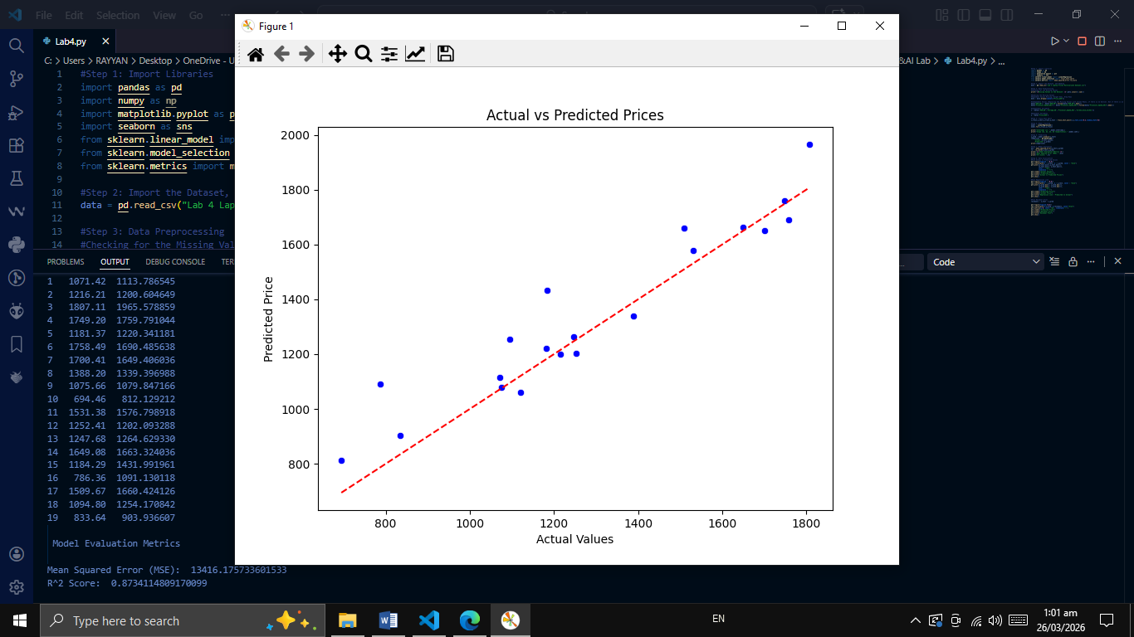
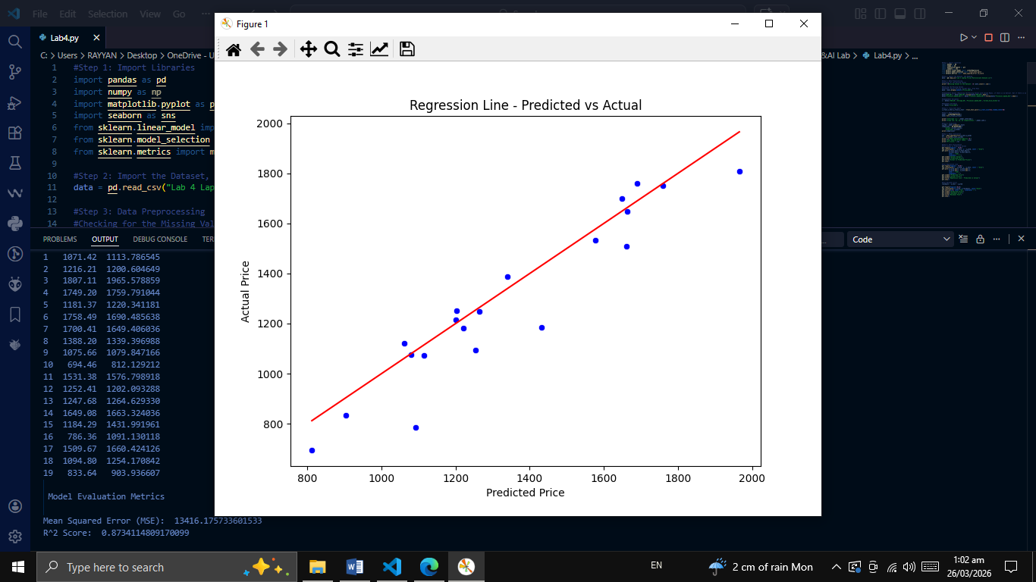
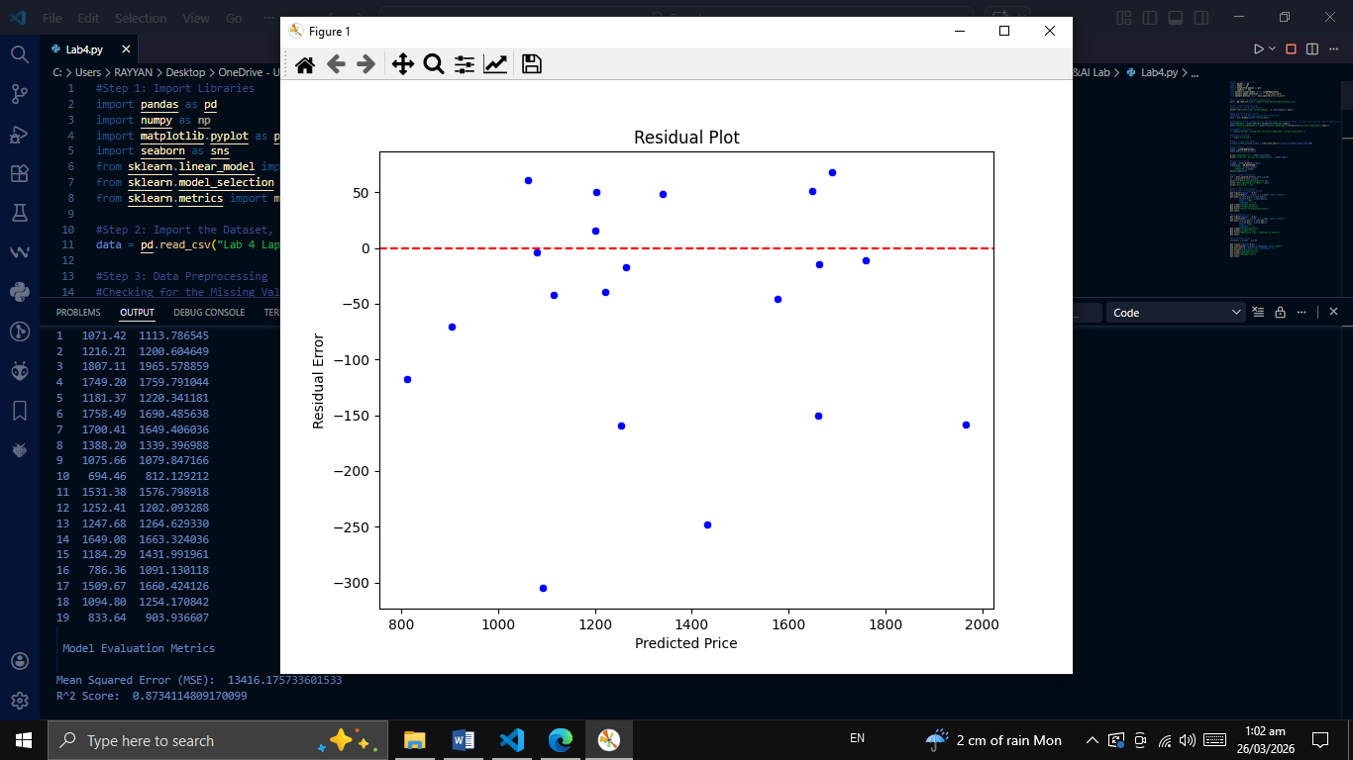
______________________________________________________________________________
THE END

